NEXT JS

1. npx create-next-app or yarn
2. dev srcript is use for server startup
3. static files like images ,css are stored in public folder.
4. Pages contan the pages
5. To run by npm run dev
6. Import is not necessary
7. Index is the default name of the page.
8. Navigation –
   1. Import Link from ‘next/link’
   2. Use <a> for link des
9. Api in react js use like-
   1. 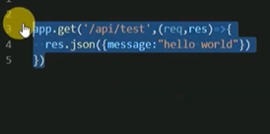

In next js use like-

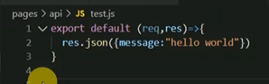

1. Get data in next js threw

a-getStaticProps()- use for fetch data it works fast

b-getServersideProps()- use for data fetching when we fetch data from a user specific page then use serversideprops.

1. Styling

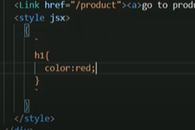

1. NavBar

Use layout to call navbar in all pages.

We use _app.js to receive indivisual component and pages.

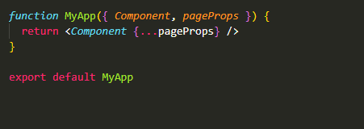

1. Use materialize for frontend design

The next js has a special component known as Head.

1. Make isAcitive function for background active onCklick it.
2. Install mongoose

Here we use import but in node js use require to import mongoose.

1. Mongobd create project name
2. Create cluster
3. Database access create user
4. Network access- add ip address from anywhere
5. Go to cluster and click on connect
6. Copy link
7. Create .env.local
8. Crete initDB.js file for connection stablish
9. Create model-

We define collections mainually.

Database name

Add collection name products

Add records mainually

1. Create api for product
2. Show product in home page the product is not user specific so we use getStaticProps() function.
3. Return data in products and pass in props
4. Add card and iterate in home page.
5. Key={product._id} use for product itration
6. Add style externally file
7. Api route

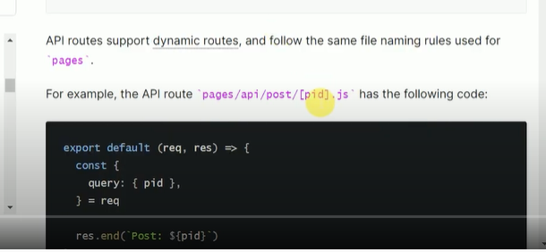

1. Dynamic api routing threw gerServersideprops-

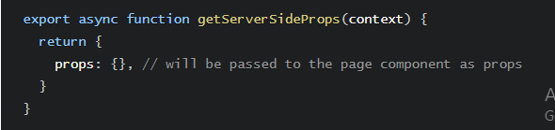

1. Dynamic api routing threw setStaticProps-

It is more faster then gerserversideprops

1. Display all detail and stablish delete operation on product
2. Crate a ui for create product
3. preventDefault is use for not refresh the page
4. add product and display image in down by using crearteobjecturl

 <img className="responsive-img" src={media?*URL*.createObjectURL(media):""} />

1. npm i bcryptjs jsonwebtoken js-cookie
2. before making signup api make model.the model name is user.